HOSTEL MANAGEMENT SYSTEM
24-11-2025

Introduction

Purpose
The purpose of the Hostel Management System (HMS) is to provide an efficient and automated solution for tracking hostel students when they go out for outings and ensuring they return on time using biometric authentication methods such as fingerprint, RFID card, or face recognition. The system monitors real-time entry and exit activities through biometric devices and updates the student’s outing status automatically.
To enhance safety and accountability, the HMS sends automated SMS notifications to parents and hostel wardens if a student fails to return by the scheduled time. The system also generates detailed statistical reports and insights for hostel authorities to support monitoring, decision-making, and overall hostel administration.

KEY POINTS
- Record students
- User data XL, upload provision
- Software Dashboard (Present and not present count)
- Multiple Hostel linking provision
- Multiple readers connection
- Cut off time should be configurable
- Track expected return time vs actual return time.
- Send SMS alerts to parents and warden if a student is late.
- Maintain complete log/history of all outings.
- Generate statistics and reports (daily, weekly, and monthly).
- Provide dashboards for administrators, wardens, and management.
- Automatic data sync form one device to another devoice

Users
- Admin
- Hostel Warden / In-Charge
- Parents (view notifications only)
- Students

Operating Environment
- Web-based application
- Runs on Windows/Linux server
- Uses SMS gateway for mobile notifications

Functional Requirements

Student Management
- FR1: System shall allow Admin to register students.
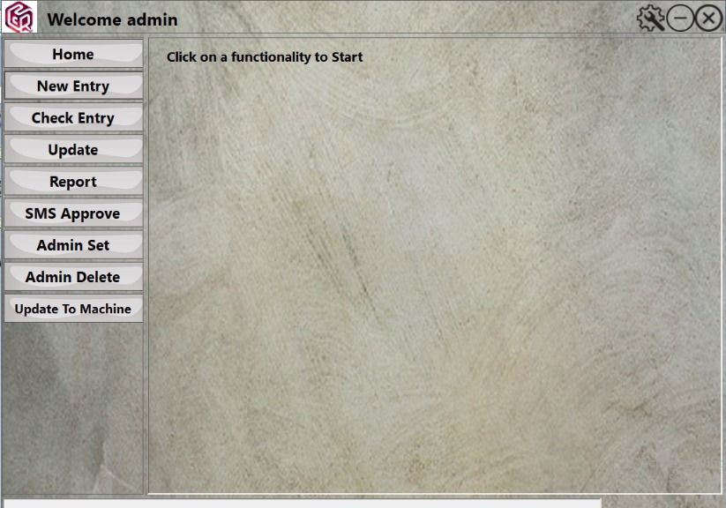
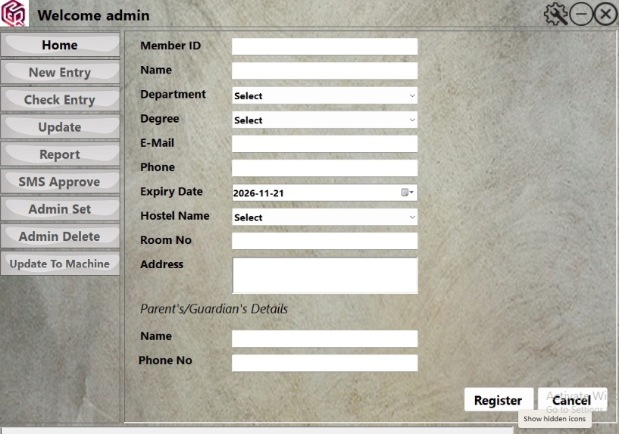

- FR2: System shall store all registration data’s as listed above.
- FR3: System shall allow wardens to view student profiles.
- FR4: System shall allow edit student profiles.

Tracking & Alerts
- FR5: System shall automatically track overdue students.
- FR6: System shall send SMS alerts to parents & wardens when a student is late.
- FR8: System shall mark outing as “Completed” after return verification.

Reporting & Statistics
- FR9: System shall generate daily report of all outings.
- FR10: System shall generate monthly statistics:
  - Total outings
  - Late returns
  - Student-wise outing count
  - Category -wise trends
- FR11: Reports shall be downloadable (PDF, Excel).

User Management
- FR12: System shall support role-based access (Admin/Warden).
- FR13: System shall log all user activities.

Non-Functional Requirements

Security
- Secure login with encrypted passwords.
- Role-based permissions.
- All sensitive data (phone numbers, student profiles) must be encrypted.

Usability
- Simple user interface for wardens.
- Mobile compatible dashboard.

Reliability
- Automatic backup daily.

Database Requirements (High Level)

Student Table
- Student ID
- Name
- Department
- Degree
- Email
- Phone number
- Room Number
- Parent Name
- Parent Phone
- Hostel name
- Status (Active/Inactive)
- Expiry date
- Address – not mandatory

SMS Notification Rules
Condition | Action
Student is late by 0 minutes | Send SMS to parent + warden
Late by 30 mins | Send follow-up reminder
Returned | Send status update (optional)

Existing software screens:


 